HANOI UNIVERSITY OF SCIENCE AND TECHNOLOGY



**SCHOOL OF ELECTRONICS AND TELECOMMUNICATIONS**



PROJECT REPORT

**DESIGN AND DEVELOP AN APPLICATION FOR HOME APPLIANCE CONTROL USING HAND GESTURES**

Name of group: N6

|  |  |
| --- | --- |
| Student Name | Student ID |
| Đồng Quốc Đạt | 20203795 |
| Trần Doãn Hoàng | 20203820 |

Name of instructor: Assoc. Prof. Lê Thị Lan

Hanoi, February 2023

**PREFACE**

As the world becomes more digitally advanced, home automation has become increasingly popular. With the rise of smart homes, controlling appliances through a smartphone has become a common practice. However, this method still involves manual interaction, which can be inconvenient at times. This report introduces an innovative way to manage home appliances using hand gestures.

This report aims to design and develop an application that enables home appliance management using hand gestures. The application uses machine learning algorithms to detect and recognize specific hand gestures to control appliances. The system is designed to simplify the process of managing home appliances, enabling users to interact with their devices without any physical contact.

The report is structured to provide a comprehensive understanding of the application's system management, including the requirements, system architecture, and implementation. The report concludes with the results of the testing and validation process, which demonstrate the effectiveness of the application in managing home appliances using hand gestures.

Overall, this report presents an innovative solution to the traditional way of managing home appliances. It showcases the potential of using machine learning algorithms to simplify our interaction with our surroundings, making it more convenient and accessible for everyone.

Table of contents

|  |  |  |  |
| --- | --- | --- | --- |
| **CHAPTER 1: SYSTEM ANALYSIS AND DESIGN** | **I. System Requirements** | 1. Hardware and software | 6 |
|  |  | 2. Functional and non-functional requirements | 6-8 |
|  | **II. Design Analysis** | 1. Block diagram | 8 |
|  |  | 2. Business Function Diagram | 9 |
|  |  | 3. Use Case Diagram | 10-12 |
|  |  | 4. Activity Diagram | 12-13 |
|  | **III. Database Analysis** | 1. Entity Relationship Model | 13-14 |
|  |  | 2. Relationship-Relationship Model | 15-16 |
|  | **IV. Programming Analysis** | 1.Initiating App and Creating Database | 16-17 |
|  |  | 2. Authentication | 18-20 |
|  |  | 3. User Interface | 20-23 |
|  |  | 4. Hand gesture dectection | 23-25 |
|  |  | 5. Contact and Feedback | 25-26 |

|  |  |  |  |
| --- | --- | --- | --- |
| **CHAPTER 2: SYSTEM EXPERIENCE AND TESTING** | **I. How to perform** | 1. Experimenting with login and account creation features | 27 |
|  |  | 2. Experimenting with add rooms and devices | 27 |
|  |  | 3. The video streaming feature will have to pass the following test cases | 27-28 |
|  | **II. Interface** |  | 28-32 |
| **CONCLUSION** |  |  | 33 |
| **REFERENCES** |  |  | 34 |

CHAPTER 1: SYSTEM ANALYSIS AND DESIGN

**I. System Requirements**

System requirements are a crucial aspect of software development as they define the capabilities and features of the system being developed. The system requirements specify the hardware and software components required to build the system, as well as the functional and non-functional requirements that must be met to ensure the system's effectiveness.

**1. Hardware and software**

*a. Hardware*

* laptop or desktop
* camera or webcam

*b. Software*

* Python programming language
* Machine learning framework (e.g., TensorFlow, Keras, PyTorch)
* OpenCV (Open-Source Computer Vision Library)
* Flask (Python web framework)
* HTML, CSS, JavaScript (for user interface)

**2. Functional and non-functional requirements**

*a. Functional Requirements:*

REQ-1: The application should be able to detect and recognize hand gestures to control home appliances.

REQ-2: The application should provide a user-friendly interface for the user to interact with the application.

REQ-3: The system should be able to control multiple appliances simultaneously, competiable with different interface.

REQ-4: The system should be able to store the user's preferences for each appliance.

REQ-5: The system should be able to provide real-time feedback on the status of each appliance.

REQ-6: All users shall be able to log into the application using a valid username and password.

REQ-7: Users must first register in order to get a username and password to login.

REQ-8: Users can log out of current user’s account on the application

REQ-9: Users have the ability to add/remove devices that can be controlled to avoid unfortunate incidents, especially with children.

REQ-10: Users have the ability to add/remove rooms where the app can use to ensure privacy.

REQ-11: Check the status of the smart home for timely maintenance and replacement, ensuring a comfortable life.

REQ-12: As a user, I will be able to control my television without the remote.

REQ-13: As a user, I will be able to open and close curtains automatically.

REQ-14: As a user, I will be able to lock and open the door without touching.

REQ-15: As a user, I will be able to lock my laptop immediately from distance.

REQ-16: As a user, I will be able to receive a photo taken randomly from my security cameras whenever I want.

REQ-17: As a user, I will be able to control my air conditioner without the remote.

*b. Non-Functional Requirements:*

REQ-18: The system should have high accuracy and low latency in detecting and recognizing hand gestures.

REQ-19: The application should be able to run on low-cost hardware devices.

REQ-20: The system should be secure and protect user data from unauthorized access.

REQ-21: The system should be scalable and able to handle an increasing number of users and device.

**II. Design Analysis**

**1. Block diagram**

The block diagram of the system is shown in Figure 1.1. The camera image inside the house is collected and analyzed through the developed server. The results of the recognition will be sent to the management module to update the database. The program's functions and interface are developed on the client side to allow users to connect to the database and perform tasks.

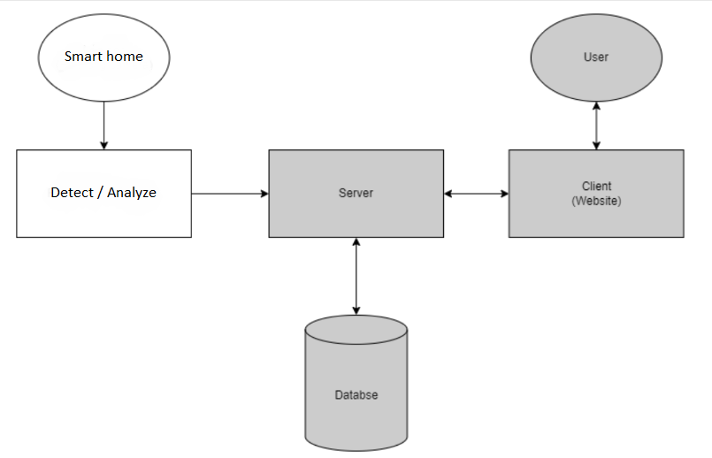

*Figure 1.1: Block diagram of smart home appliance*

**2. Business Function Diagram**

There are four main features for functions included in the system:

* User Interface: The user interface is responsible for receiving input from the user in the form of hand gestures and displaying the current status of the home appliances.
* Gesture Recognition: The gesture recognition function is responsible for processing the input received from the user interface and recognizing the specific hand gestures.
* User Management: The user management function is responsible for managing user accounts and permissions, ensuring that only authorized users can control the home appliances.
* Database Management: The database management function is responsible for managing the database containing the user's preferences and the current status of the home appliances.

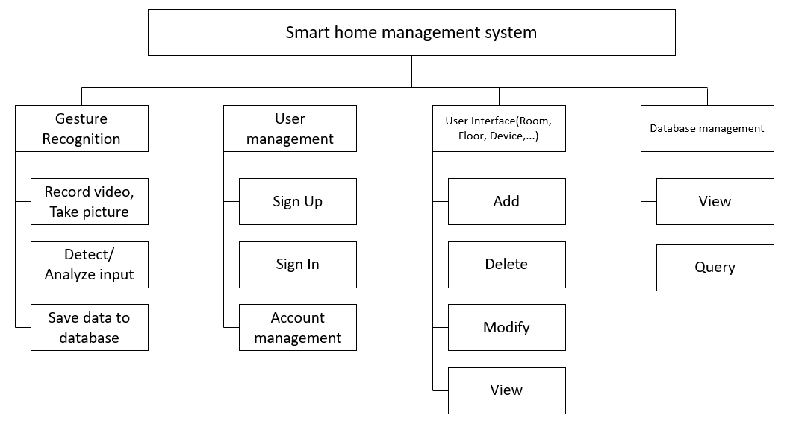

*Figure 1.2: BFD of smart home appliance*

**3. Use Case Diagram**

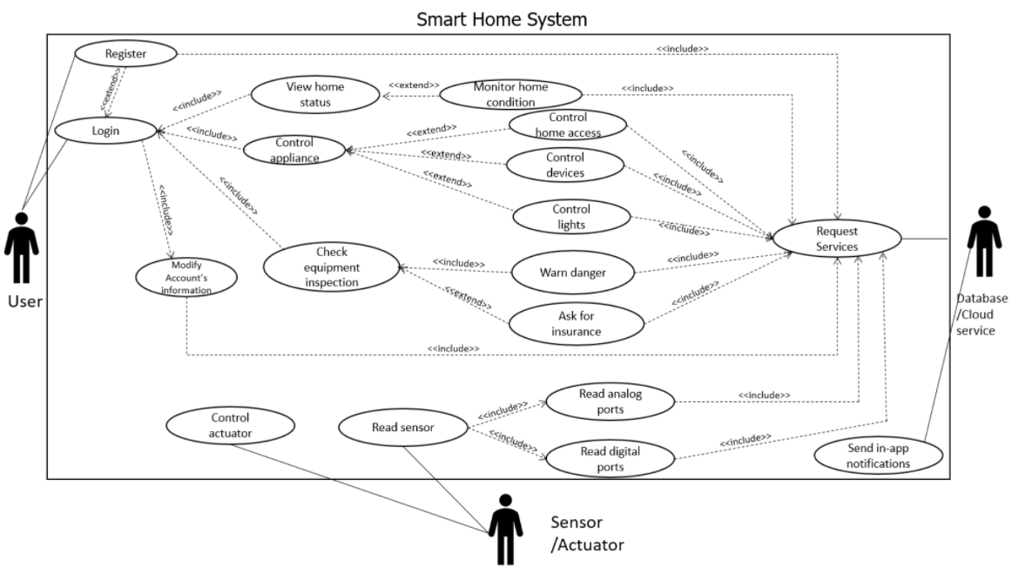

*Figure 1.3: UC diagram of smart home appliance*

**Casual Discription**

|  |  |  |  |
| --- | --- | --- | --- |
| Usecase name | Actor | Actor’goal | System Requirements |
| UC-1: Register | User, Database/Cloud Service | To create an account | REQ-7, REQ-21 |
| UC-2: Login | User, Database/Cloud Service | To restrict access to  user only (login  authentication through  email and  password) | REQ-6, REQ-20 |

|  |  |  |  |
| --- | --- | --- | --- |
| UC-3:  Control Appliance | User, Database/Cloud Service, Sensor/Camera | To enable/disable  automatic alarm,  automatic camera,  automatic lights  functionality, as well as  the sensors | REQ-2, REQ-3, REQ-4, REQ-10, REQ-19 |
| UC-4: User Logout | User, Database/Cloud Service | To logout of current  user account on the  application | REQ-8 |
| UC-5: Warn danger | User, Database/Cloud Service, Sensor/Camera | To be able to call 911 if  deemed necessary  according to potential  threats | REQ-5 |
| UC-6:  Control Devices | User, Database/Cloud Service, Sensor/Camera | To turn devices on/off | REQ-9, REQ-12, REQ-13, REQ-14, REQ-15, REQ-17, REQ-19 |
| UC-7: Control Lights | User, Database/Cloud Service, Sensor/Camera | To turn lights on/off | REQ-18 |

|  |  |  |  |
| --- | --- | --- | --- |
| UC-8: Control Home Access | User, Database/Cloud Service, Sensor/Camera | To turn on lights and  turn on alarm once  accelerometer sensor is  triggered, if visitor is  unknown/known | REQ-16, REQ-19 |
| UC-9: View Home status | User, Database/Cloud Service, Sensor/Camera | To see the status of home +-(e.g, temperature, humidity,..) | REQ-11, REQ-19 |
| UC-10: View Equipment inspection | User, Database/Cloud Service, Sensor/Camera |  | REQ-5 |

4. Activity Diagram

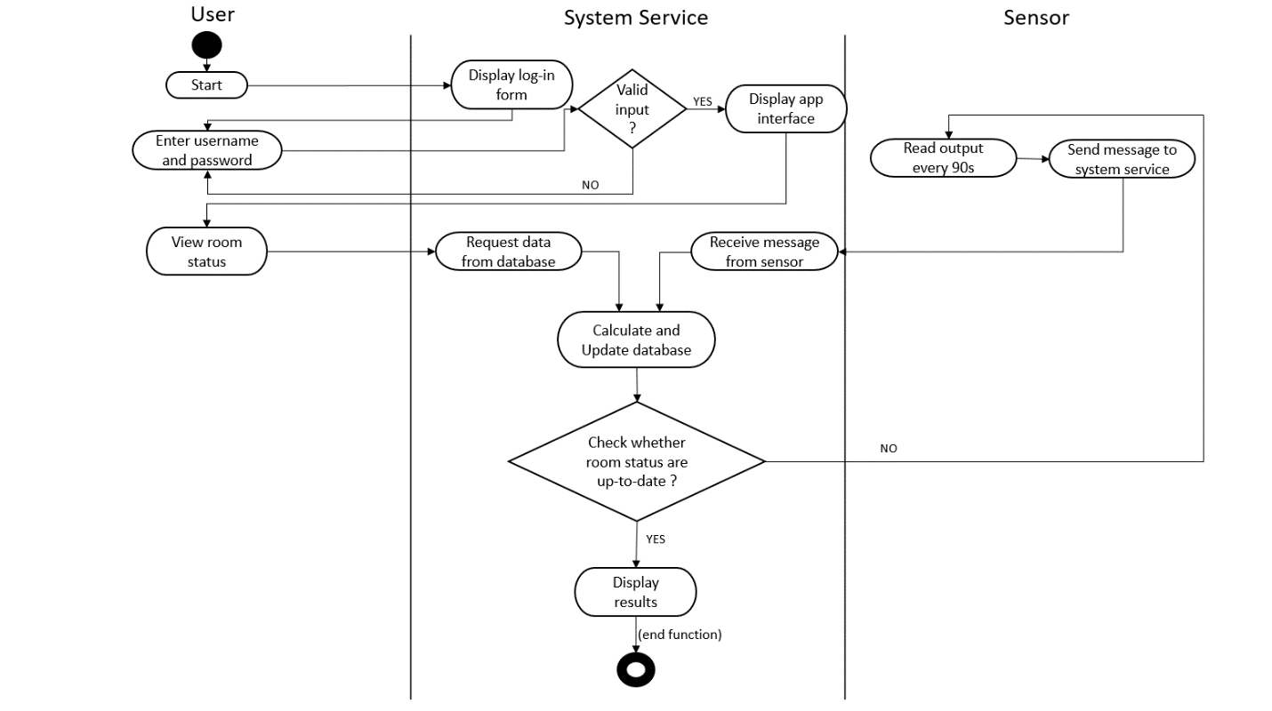*Figure 1.4: Activity diagram: View home status*

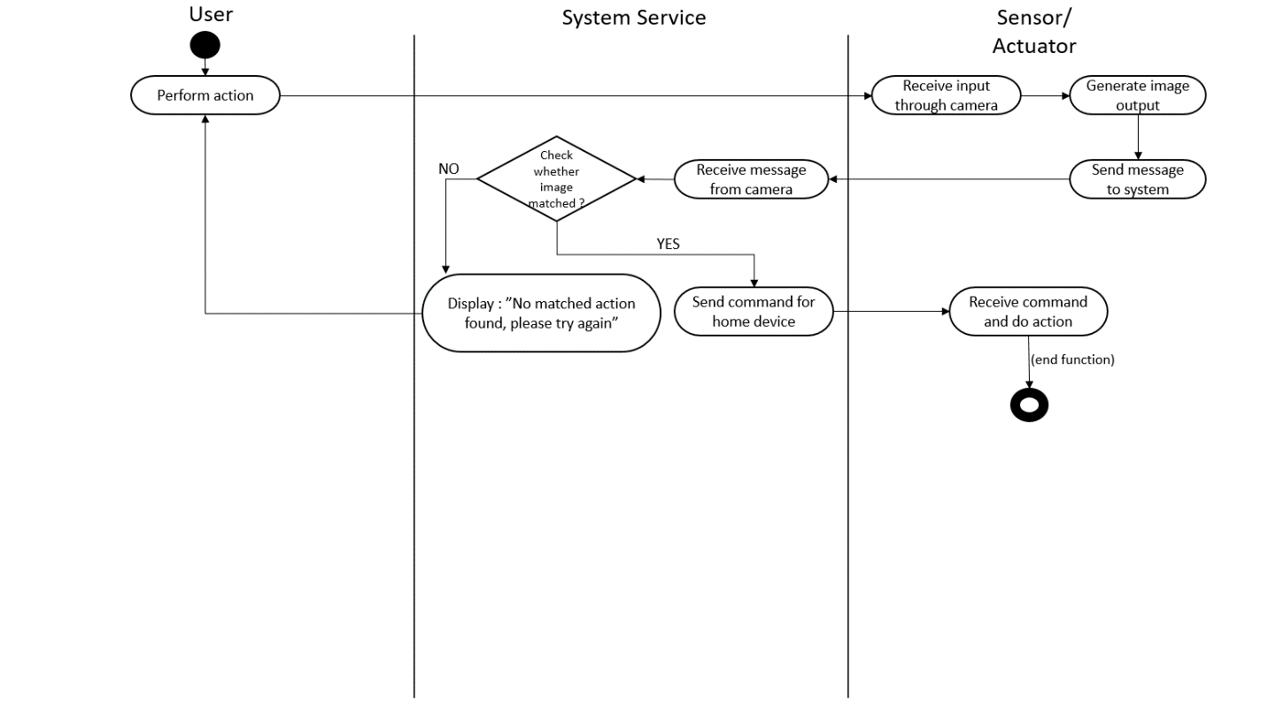

*Figure 1.5: Activity diagram: Control Appliance*

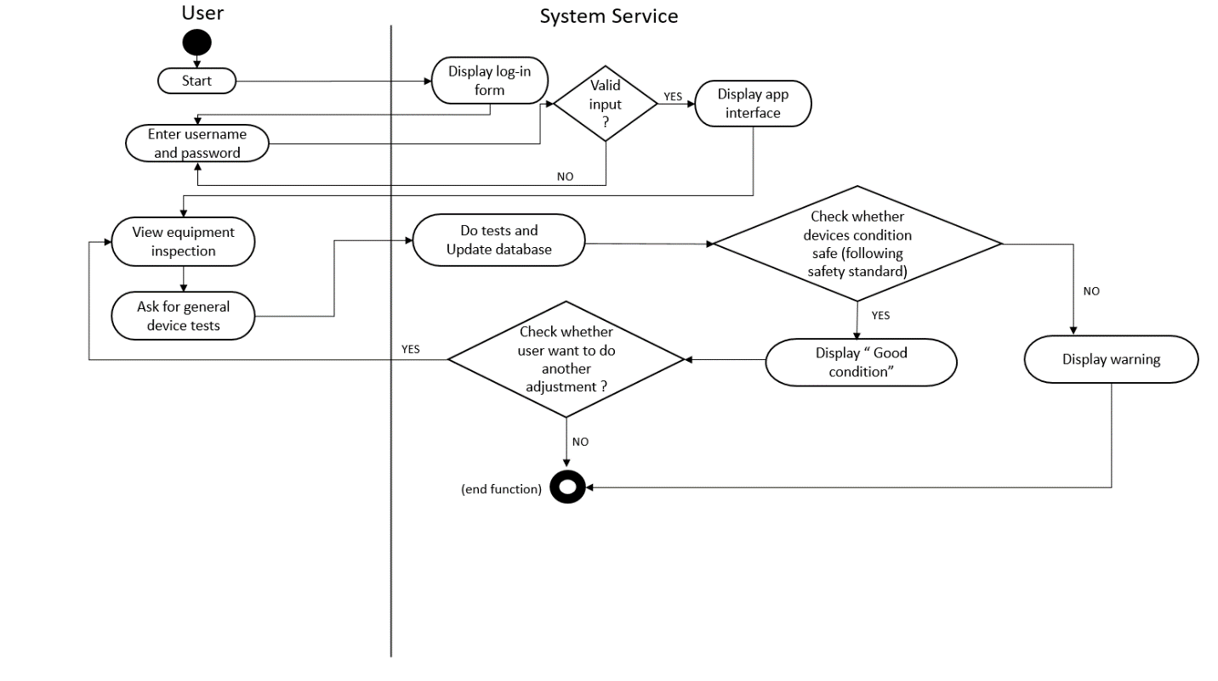

*Figure 1.6: Activity diagram: View equipment inspection*

III. Database Analysis

1. Entity Relationship Model

* The **User** model represents users of the home automation system and has a *one-to-many* relationship with the **Floor, Room**, and **Device** models.
* The **Floor** model represents the floors in a house and has a *one-to-many* relationship with the **Room** model. It also has a foreign key column referencing the **User** model.
* The Room model represents the rooms in a house and has a *one-to-many* relationship with the **Device** model. It also has foreign key columns referencing the **Floor** and **User** models.
* The **Device** model represents the devices in a house and has foreign key columns referencing the **Room** and **User** models.
* Overall, this schema allows for the storage of information about users, the floors in their house, the rooms in each floor, and the devices in each room.

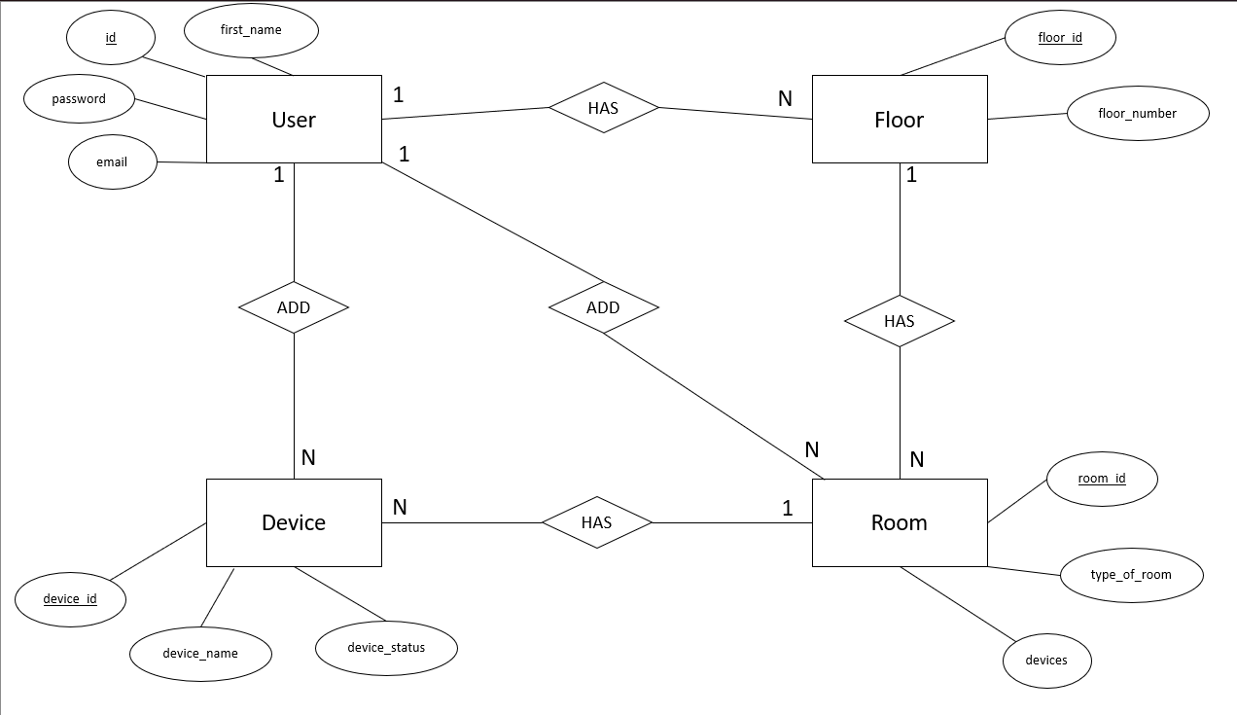

*Figure 1.7: ER Model*

2. Relationship-Relationship Model

From the ER Model, we transfer to RR Model

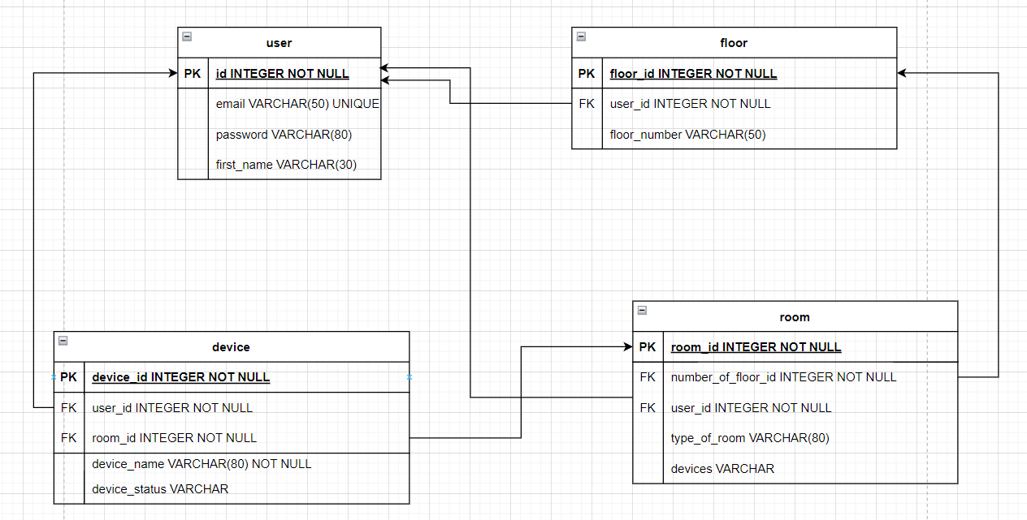

*Figure 1.7: RR Model*

|  |  |  |  |  |
| --- | --- | --- | --- | --- |
| Table | Attribute | Meaning | Type | Sample value |
| User | id | user id | int | 1 |
| email | account name | varchar | dat123@gmail.com |
| password | password | varchar | 15824689 |
| first_name | user name | varchar | Đạt |
| Floor | floor_id | floor id | int | 1 |
| user_id | user id | int | 1 |
| floor_number | number of the floor | varchar | Floor 1 |

|  |  |  |  |  |
| --- | --- | --- | --- | --- |
| Room | room_id | room id | int | 1 |
| type_of_room | room name | varchar | bedroom |
| devices | devices name | varchar | Smart Diffuser | Coffee Maker | Air Conditioner |
| number_of_floor_id | floor id | int | 1 |
| user_id | user id | int | 1 |
| Device | device_id | device id | int | 1 |
| device_name | device name | varchar | Smart Diffuser |
| device_status | device status | vachar |  |
| room_id | room id | int | 1 |
| user_id | user id | int | 1 |

IV. Programming Analysis

We choose building an app base on a Flask web application instance and sets up the configuration for the app to use a SQLite database using SQLAlchemy as an ORM (Object Relational Mapping) tool.

1.Initiating App and Creating Database

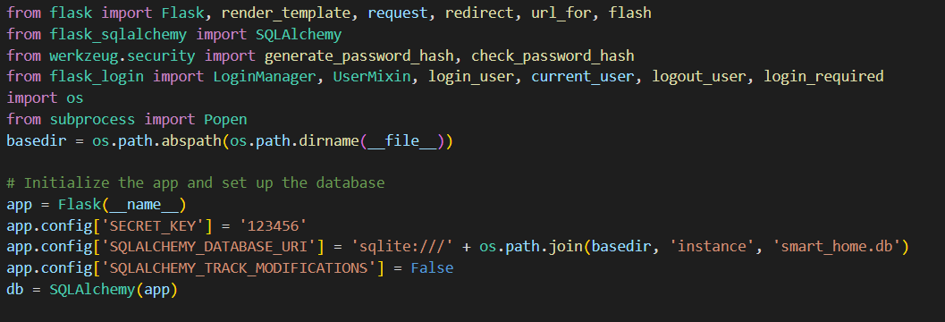

*Figure 1.8: Database Programme*

This code creates a Flask application and configures it with a secret key, a database URI, and an SQLAlchemy instance. The database URI points to an SQLite database located in the 'instance' directory of the project. The SQLAlchemy instance is then used to create an object that can be used to interact with the database.

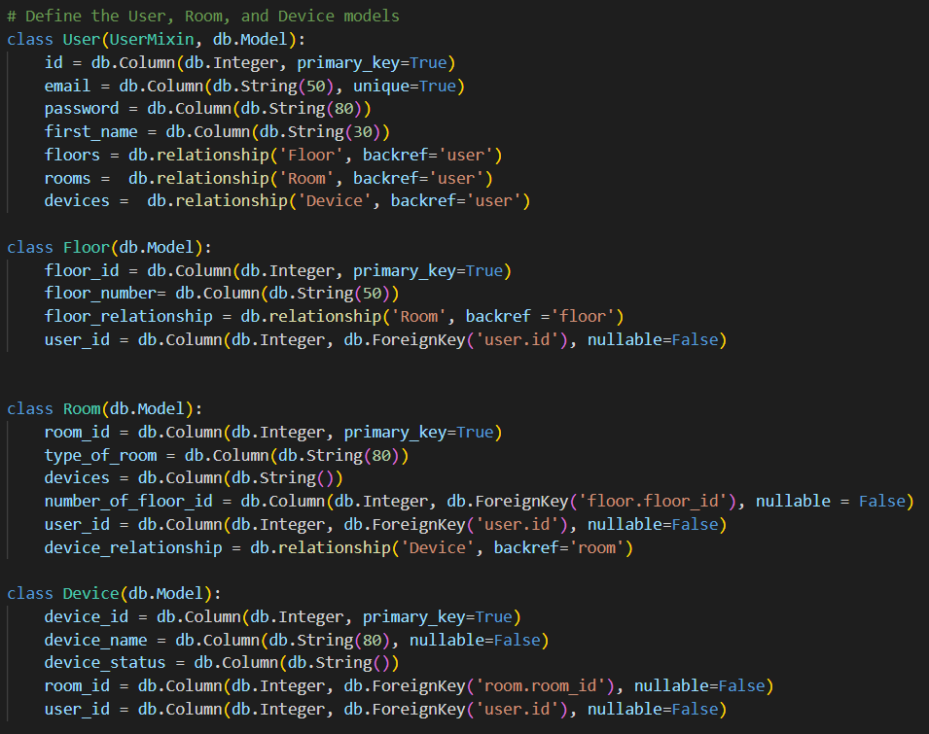

*Figure 1.9: Creating Model Programme*

This code creates four classes: User, Floor, Room, and Device. The User class contains the user's id, email, password, first name and relationships to the Floor, Room and Device classes. The Floor class contains a floor id, floor number and a relationship to the Room class. The Room class contains a room id, type of room, devices and relationships to the Floor and Device classes. Finally, the Device class contains a device id, device name, device status and relationships to the Room and User classes.

2. Authentication

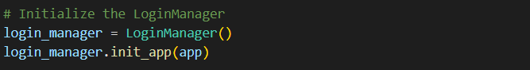

*Figure 1.10: LoginManager programme*

This code initializes the LoginManager object and sets it up with the application (app). The LoginManager is used to manage user sessions and authentication. It provides methods for logging in, logging out, and protecting views from unauthorized access.

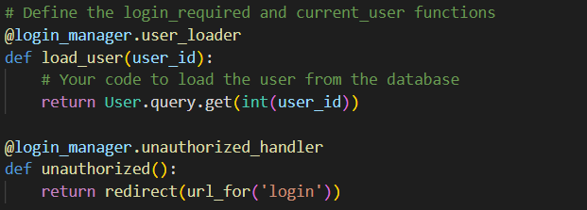

*Figure 1.11: LoginManager programme (continue)*

This code is defining two functions, login_required and current_user, which are used to control access to a website. The first function, load_user, takes a user_id as an argument and loads the user from the database. The second function, unauthorized, redirects users who are not logged in to the login page.

* Register

This code is defining a route for registering a new user. It checks if the email is already taken, and if the passwords match. If all of those conditions are met, it creates a new user in the database, adds 3 floors to their account, logs them in, and redirects them to the login page.

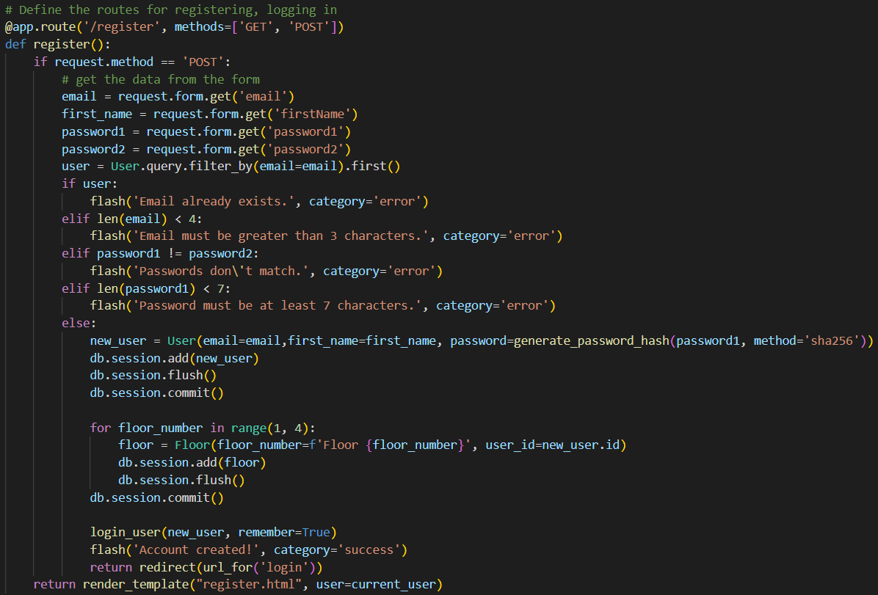

*Figure 1.12: Register programme*

* Login

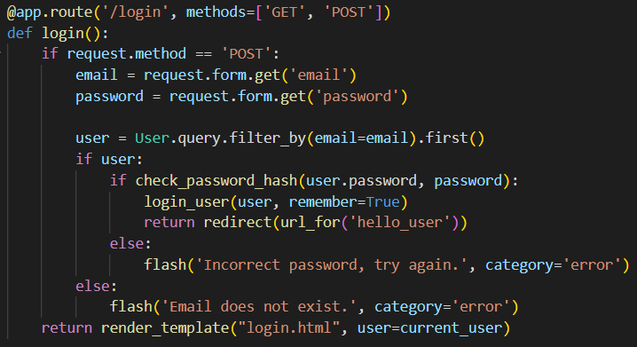

*Figure 1.13: Login programme*

This code is a route for a login page. It checks if the request method is POST, which means that the user has submitted their credentials. It then checks if the email exists in the database, and if so, it checks if the password matches the hashed password stored in the database. If it does, it logs in the user and redirects them to another page. If not, it displays an error message.

3. User Interface

**a. Home**

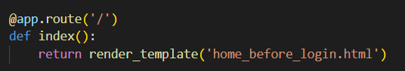

*Figure 1.14: Home_before_login app route*

This app route will be intitated first when user visit the web application



*Figure 1.15: Home_after_login app route*

After user are logged in, this app route is intitated.

**b. Floor and Rooms**

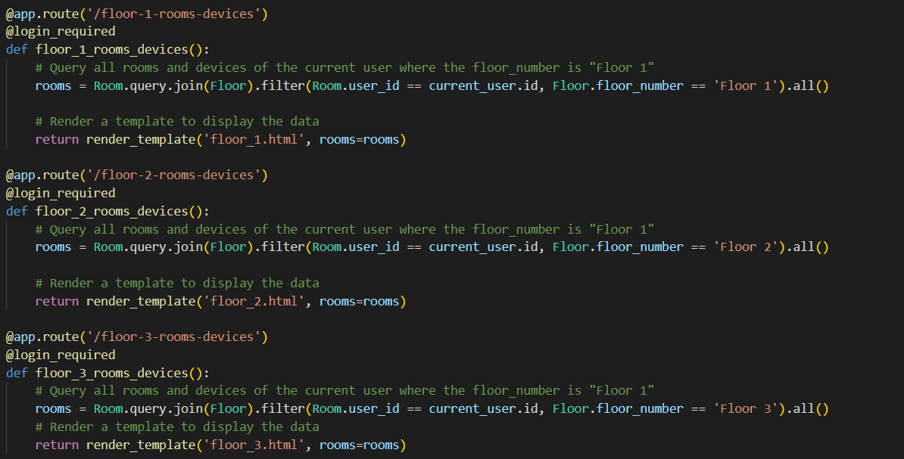

*Figure 1.16: Floor and Rooms viewing programme*

This code defines three routes that require a user to be logged in. Each route queries all rooms and devices of the current user where the floor_number is "Floor 1", "Floor 2" or "Floor 3" respectively. It then renders a template to display the data.

**c. Devices**

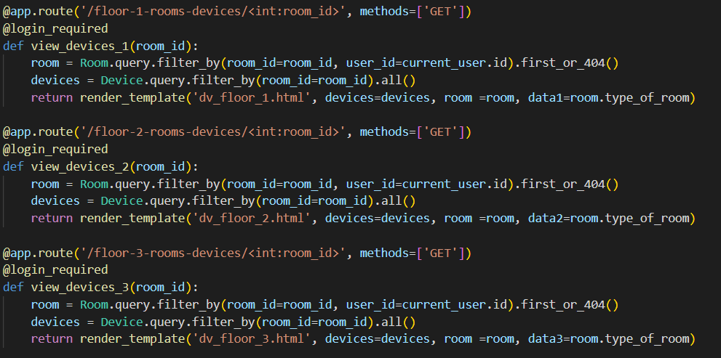

*Figure 1.17: Devices viewing programme.*

This code is a set of three functions that are used to render a template for each floor of a building. The first function, view_devices_1, takes in an integer argument called room_id and uses it to query the Room and Device databases for information about the room with that id. It then renders the dv_floor_1.html template, passing in the devices and room information as well as the type of room. The other two functions do the same thing but render different templates for floor 2 and 3.

**d. Add rooms and devices**

This code creates a route for the page 'createpage1' and requires the user to be logged in. It then checks if the request method is GET or POST.

If it is GET, it renders the template 'createpage.html'.

If it is POST, it filters for a floor with floor number 'Floor 1' and the current user's id. If it finds one, it gets a list of devices from the form, joins them together into one string with " | " as a separator, creates a Room object with that string of devices and other information from the form, adds it to the database session, and commits it to the database. It then splits up that string of devices into individual device names and creates Device objects for each of them with additional information from the form, adds them to the database session, and commits them to the database. Finally, it redirects to 'floor_1_rooms_devices'.

The same code with Floor 2 and Floor 3 respectively.

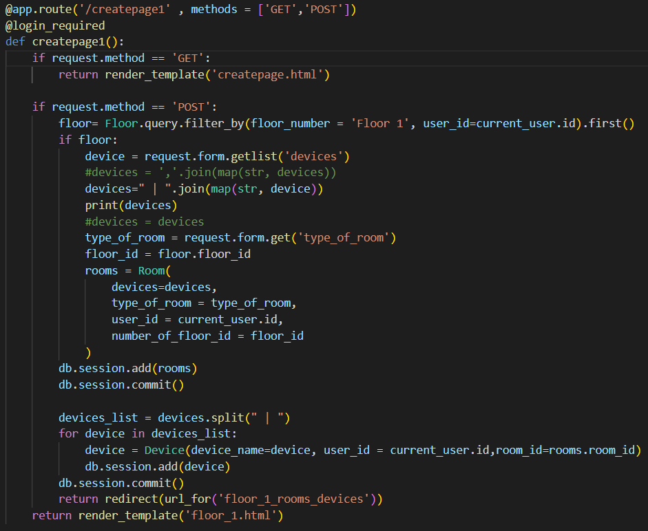

*Figure 1.18: Add room and devices programme*

e. Delete Rooms and Devices

This code creates a route for deleting a room and its associated devices from the first floor. It takes in the room's ID as an argument, queries the Room and Device tables in the database to find the room and its associated devices, deletes them, and then redirects back to the floor 1 page.

The same code with Floor 2 and Floor 3 respectively.

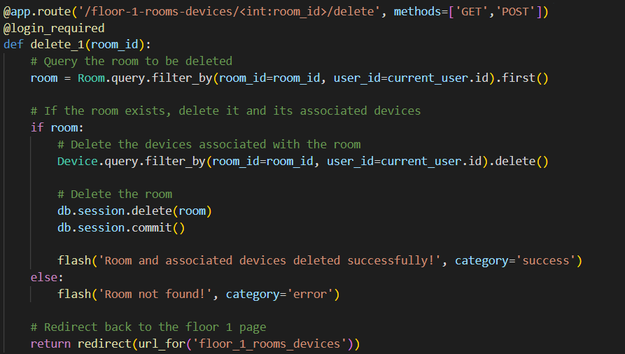

*Figure 1.19: Delete room and devices programme*

4. Hand gesture dectection

We create this function based on availabel programmes and APIs. We define 6 hand gestures with each different function to control smart bulb.

|  |  |  |
| --- | --- | --- |
| Turn on / off (toggle) | Increase brightness | Decrease brightness |
| Temp (toggle) | Randomly pick | Disco |

Input: Coordinate x, y of each key points

* + Normalized by position and size

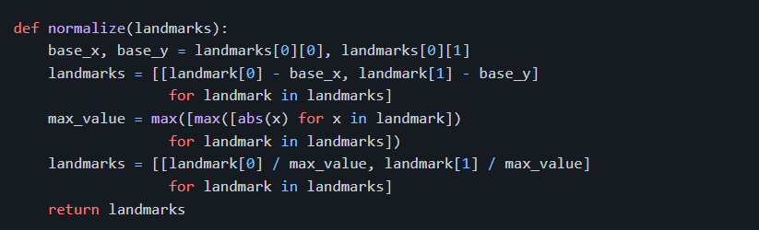

*Figure 1.20: Normalized programme*

* + Structure: [[x0, y0], [x1, y1], ..., [x20, y20]]

Output: Action

* + Model Architecture

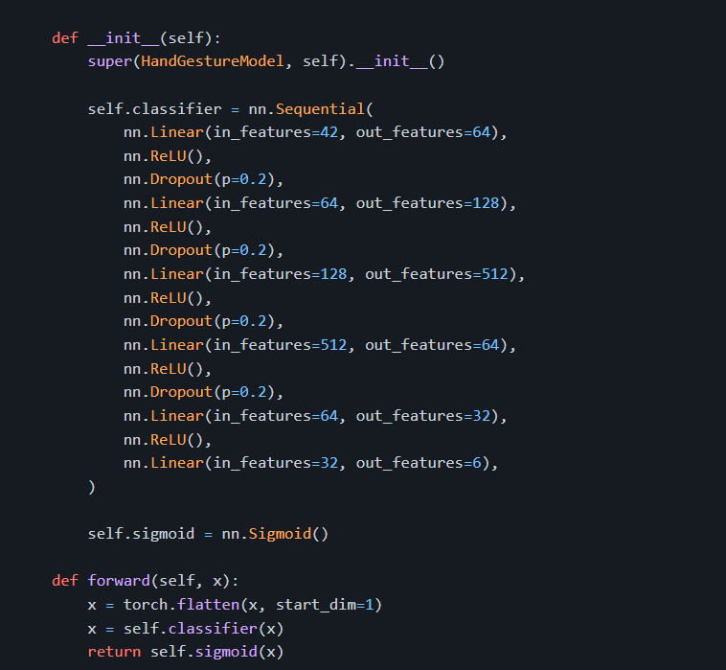

*Figure 1.21: Model Architechure programme*

5. Contact and Feedback

This is a section of a website that provides a way for visitors to contact the website's owners by email.

The first element is a heading that displays an envelope icon followed by an email address: "dat.dq203795@sis.hust.edu.vn". Below this is a line of text inviting visitors to send an email with their query.

The second element is a form where visitors can fill in their name, email address, subject of the message, and the message itself. There is also a submit button labeled "Send Message".

The form is set up to use a third-party service called Formspree to handle the email submission process. When the visitor submits the form, the data is sent to Formspree's server, which then forwards the message to the email address specified in the form action attribute.

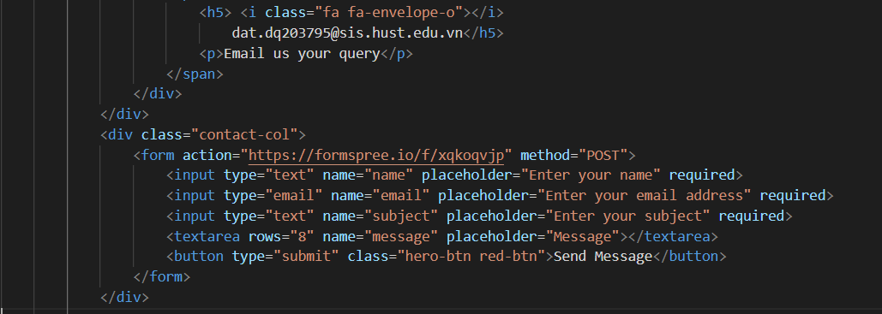

*Figure 1.22: Feedback received form programme*

We also build some questions and answers for user if they meet any problems while experiment the website.

CHAPTER 2: SYSTEM EXPERIENCE AND TESTING

**I. How to perform**

The web application is installed and deployed at: <http://127.0.0.1:5000>. To evaluate the operation of the system, I built a test script for the following functions:

1. Experimenting with login and account creation features

The login feature will have to pass the following testcases:

* Successfully logged in with correct username and password. (Pass)
* Login failed with the following username or password. (Pass)
* Successful account creation. (Pass)
* No SQL Injection errors [17]. (Pass)
* Ensure confidential information (password, token) must be encrypted. (Pass)

2. Experimenting with add rooms and devices:

* Successfully add a new room or device. (Pass)
* Ensure that the added room or device is displayed in the correct location in the user interface. (Pass)
* Ensure that the user is able to delete the added room or device. (Pass)
* Ensure that the user is not able to add a room or device without filling in all required fields. (Pass)
* Ensure that the system can handle a large number of rooms and devices without crashing. (Pass)
* Ensure that the system does not allow invalid characters or data types in the fields. (Pass)
* Ensure that the system is able to save the added room or device data properly and retrieve it correctly when needed. (Pass)

**3.** The video streaming feature will have to pass the following test cases:

* Ensure that the selected camera is correctly streaming the video feed. (Pass)
* Ensure that there is no lag or frame drops during the video stream. (Pass)

4. The data management feature will have to pass the following test cases:

* Ensure that the data is successfully added, updated, and deleted without errors or duplicates. (Pass)

5. The feedback and contact feature will have to pass the following test case:

* Ensure that we can receive the feedback. (Pass)

**II. Interface**

Some program interface images are shown in the pictures below. Users need to log in to the system as a user.

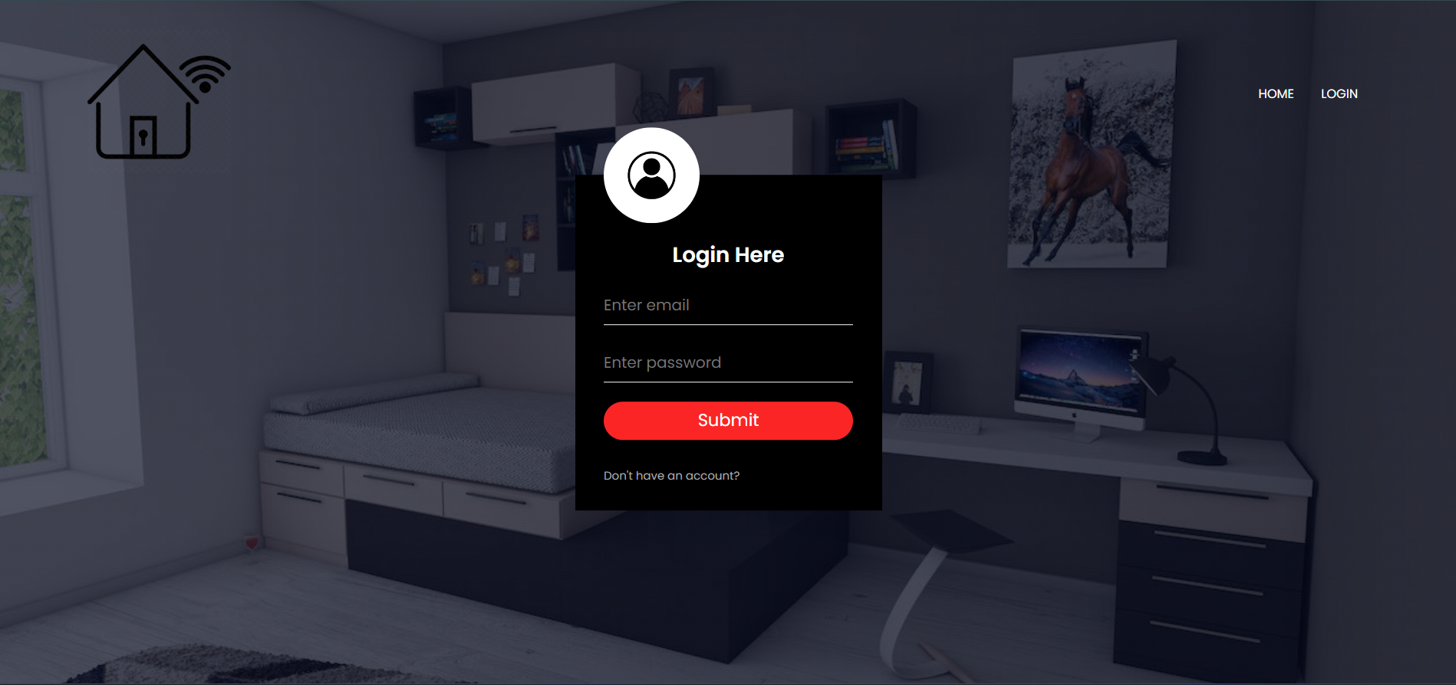

*Figure 2.1: Login interface*

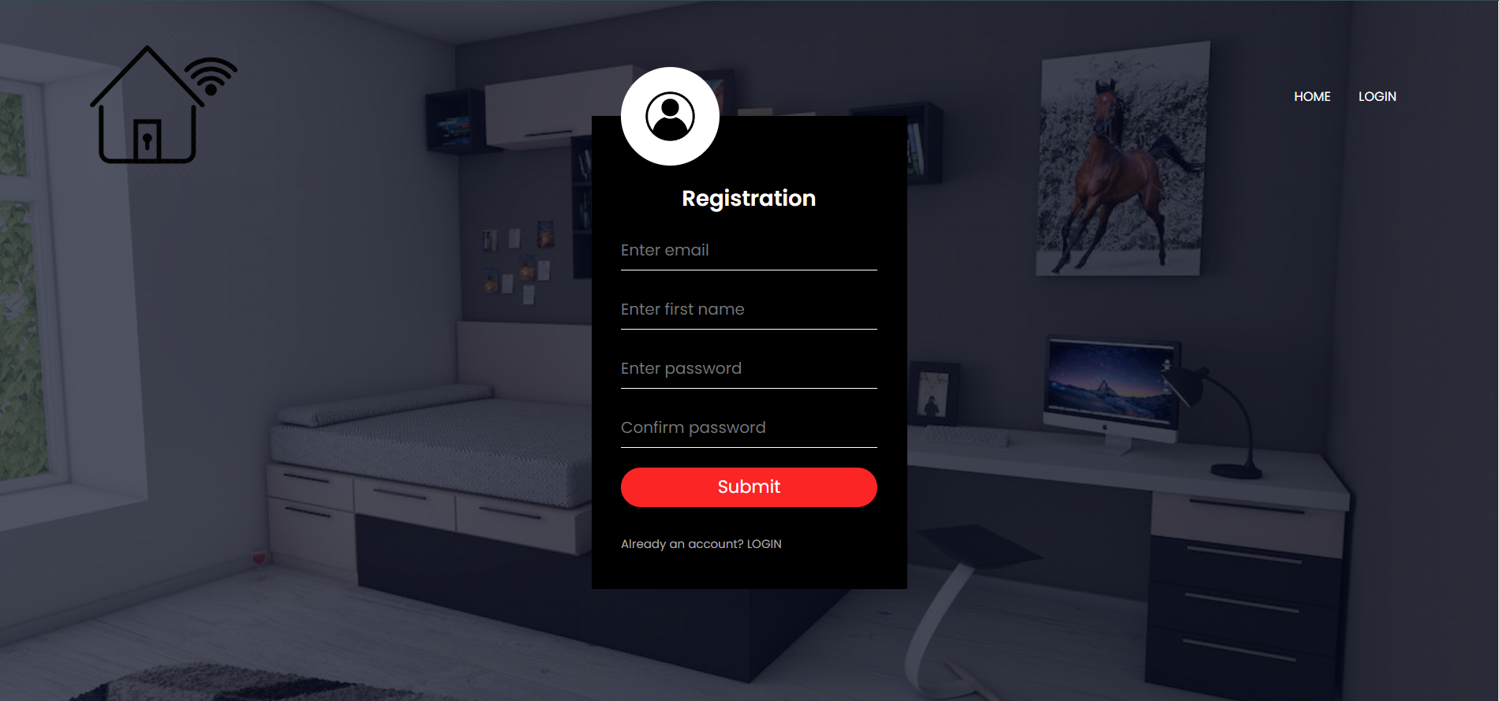

*Figure 2.2: Register interface*

After logging in, users can choose the functions on the screen including: Floor 1, Floor 2, Floor 3. User can also view times and weather.

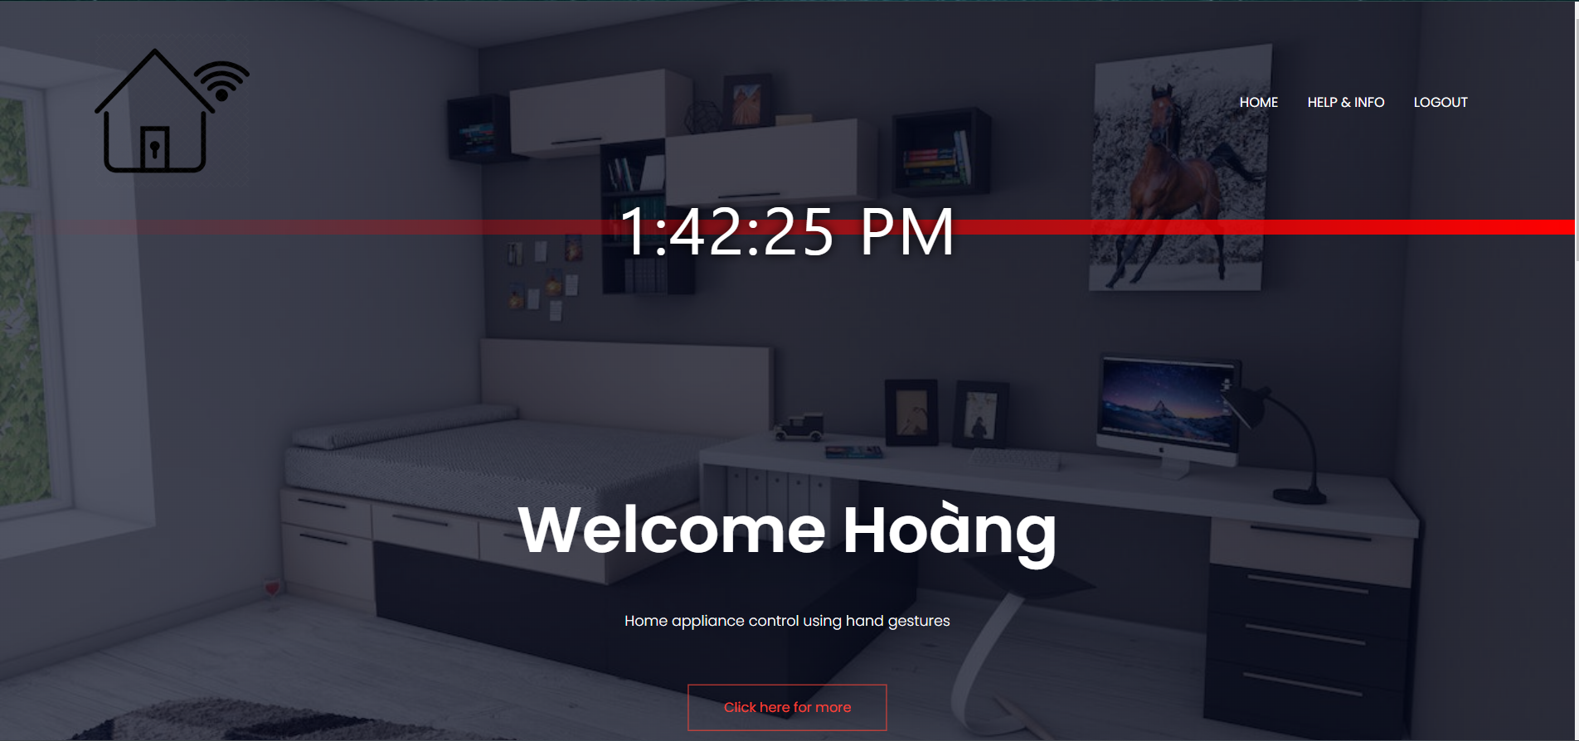

*Figure 2.3: Welcome interface*

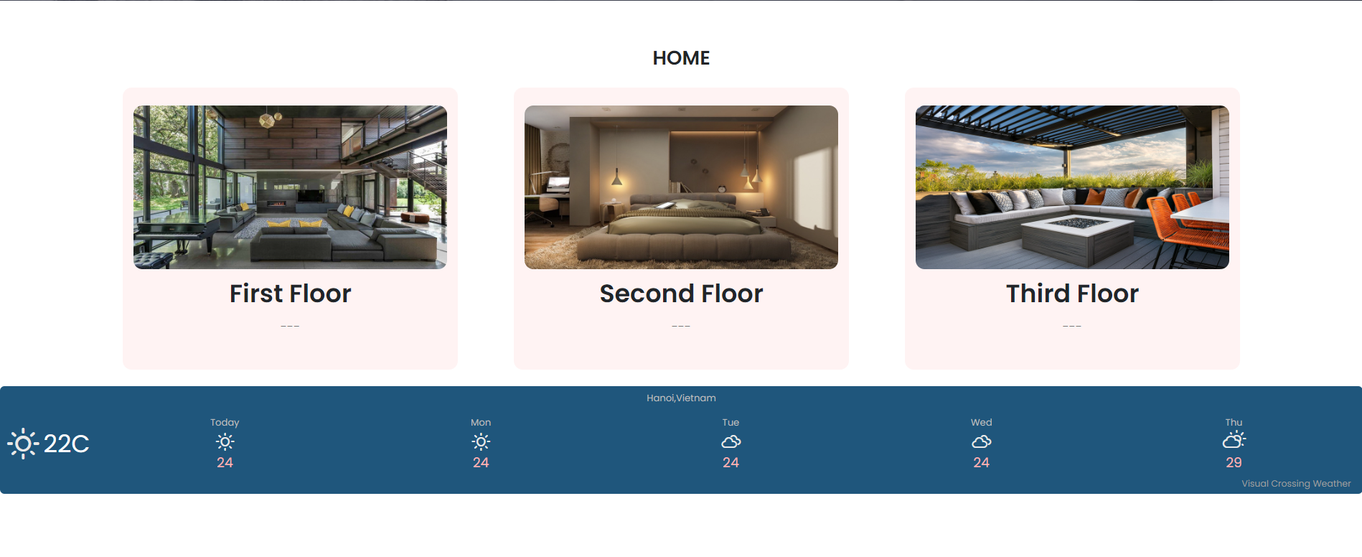

*Figure 2.4: Home interface*

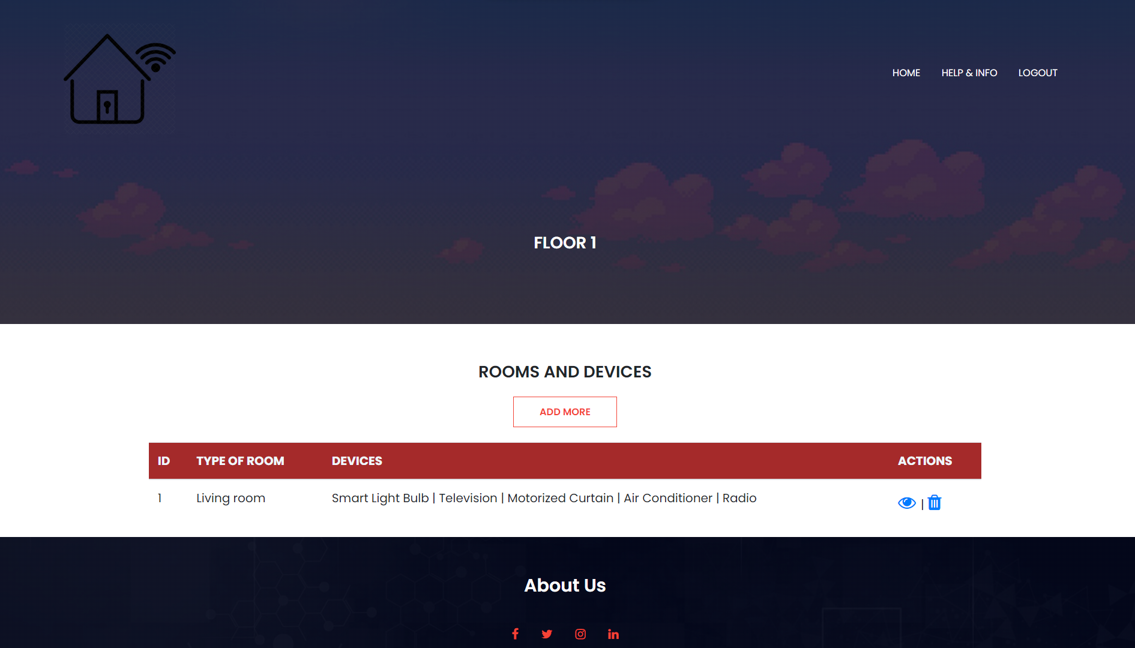

*Figure 2.5: Floor interface*

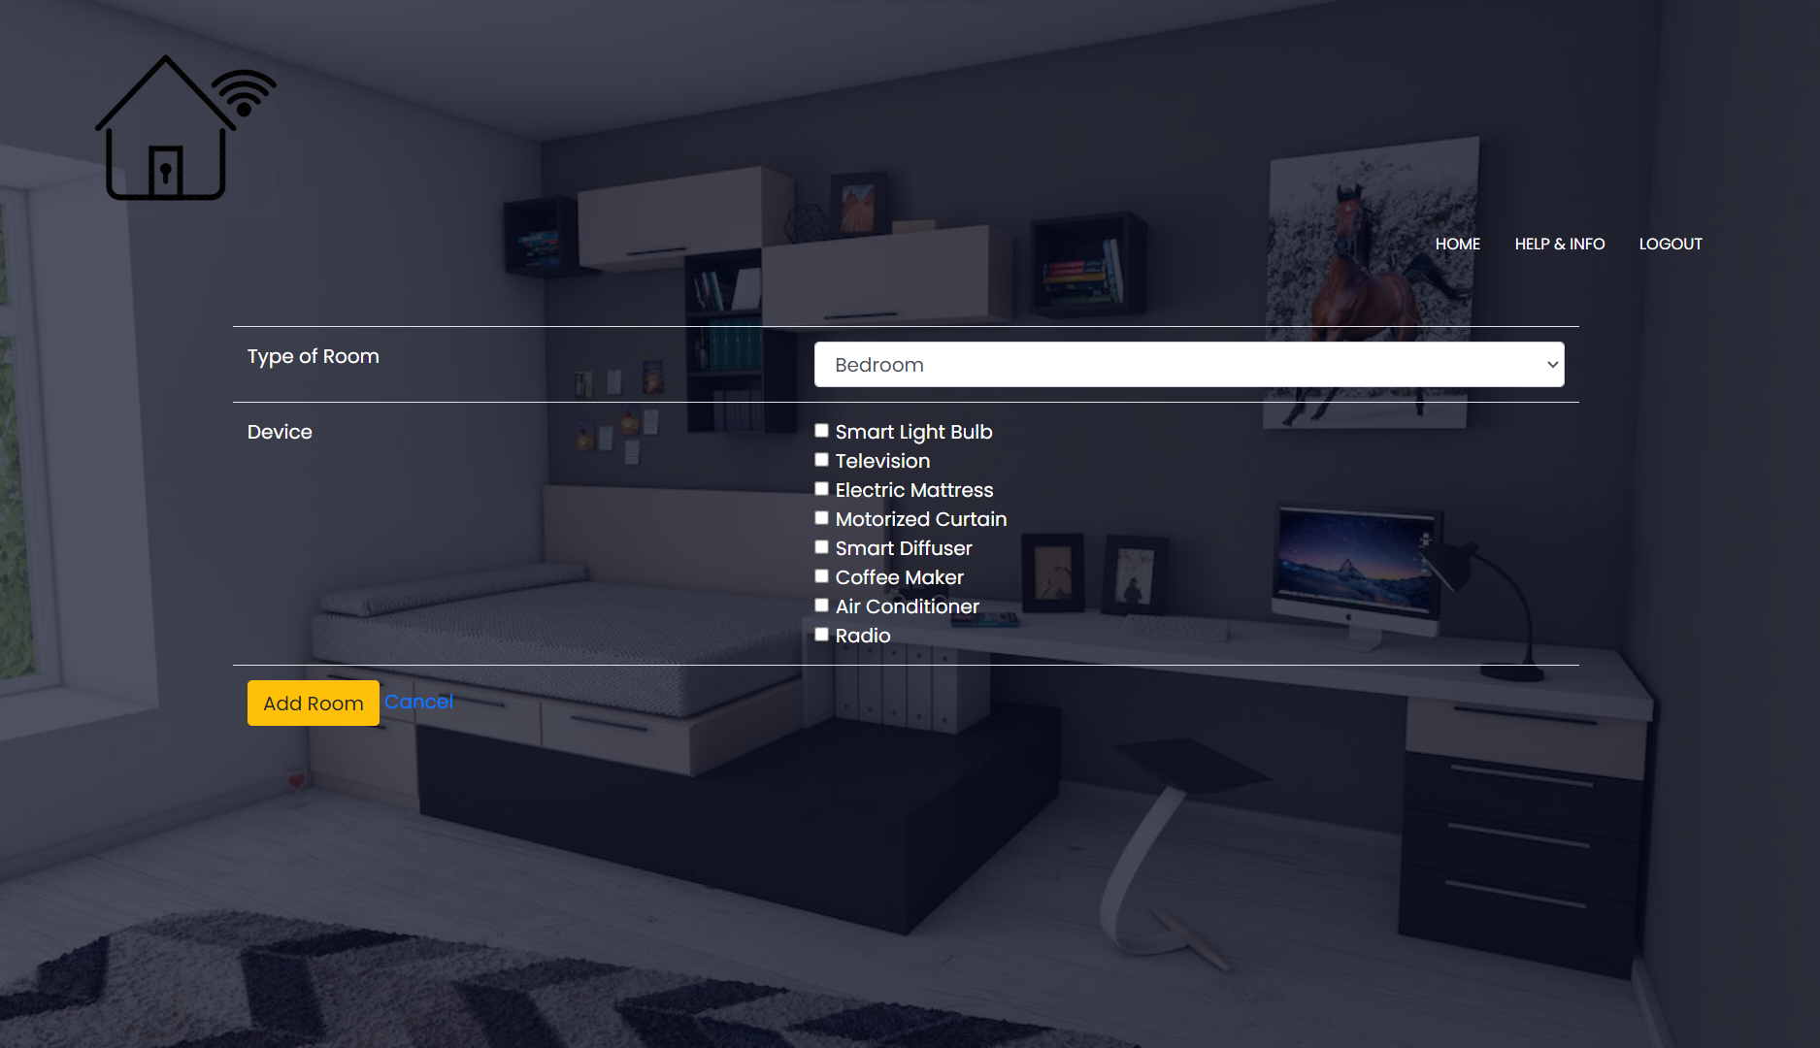

*Figure 2.6: Add room interface*

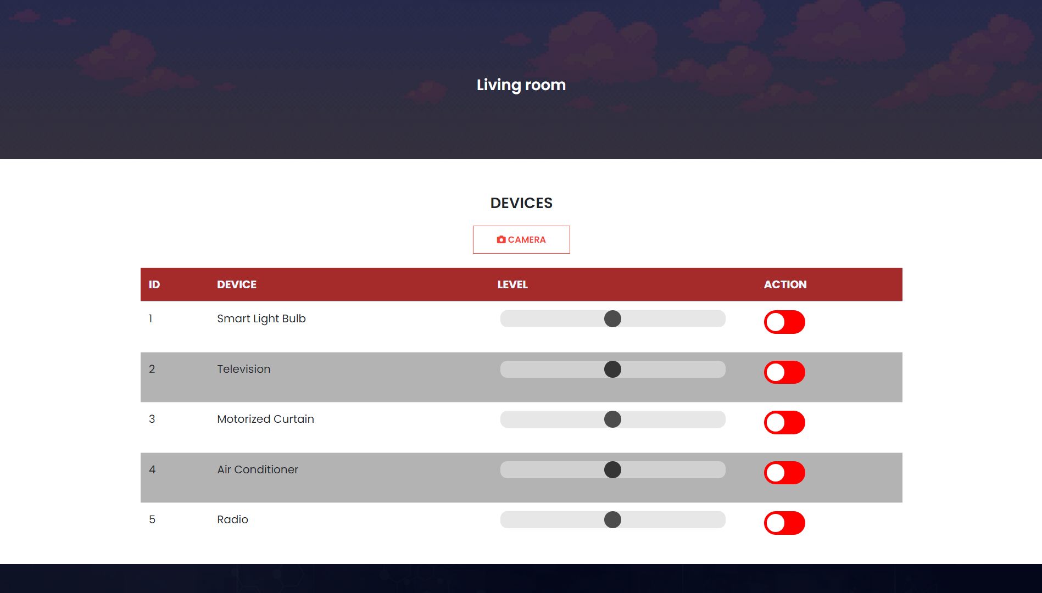

*Figure 2.7: Room interface*

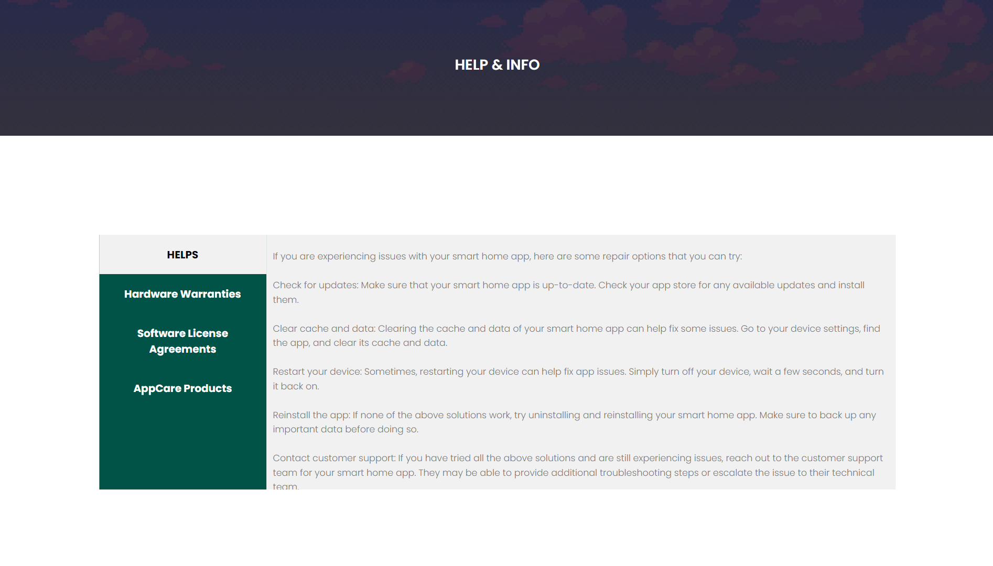

*Figure 2.8: Help&info interface*

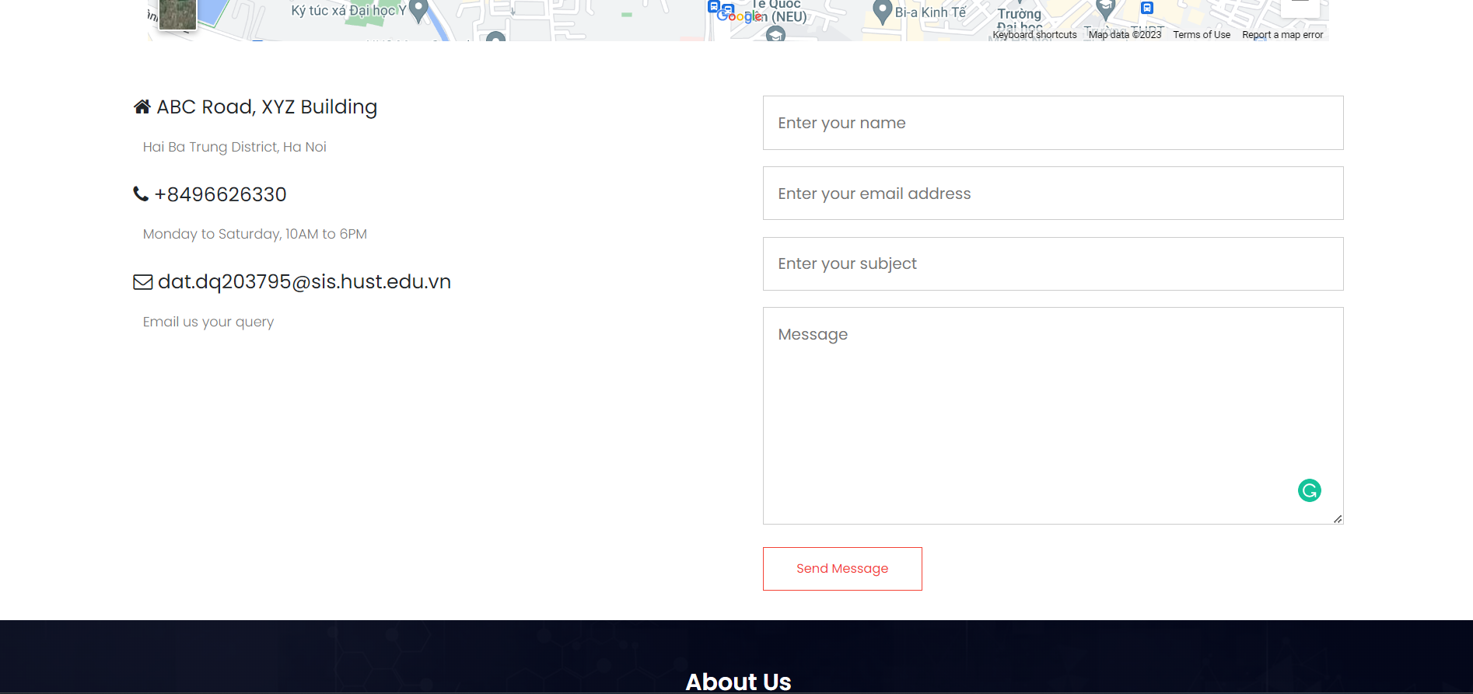

*Figure 2.9: Help&info interface (continue)*

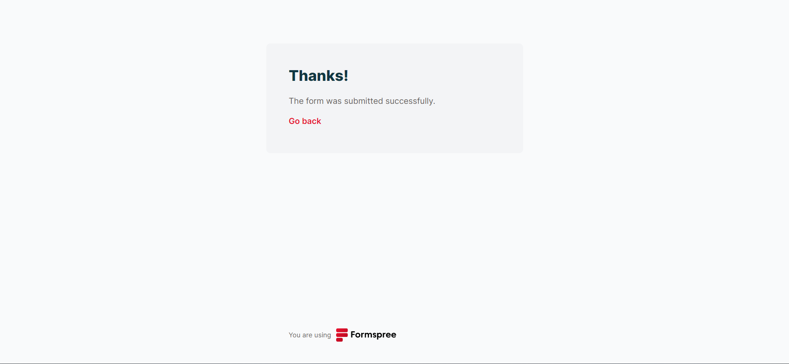

*Figure 2.10: Successful notification interface*

User can write and send feedback through form we define.Then, we can collect all your comments to inhance the web application performances.

III. Source code

Visit this link: <https://drive.google.com/drive/folders/19kcZhuZcZp3UByaZ8Zk6UrdasvNZF4R7?usp=share_link>

**CONCLUSION**

In conclusion, the development of an application for home appliance control using hand gestures has been a challenging yet rewarding experience. The project aimed to create a system that provides users with a more intuitive and convenient way of controlling their home appliances. The requirements were carefully analyzed and translated into a detailed system design that meets the functional and non-functional requirements.

The project's success depended on the effective collaboration and communication between the team members, who worked diligently to ensure that the application's requirements were met. The testing and evaluation of the application confirmed that it was able to meet the functional and non-functional requirements specified in the system requirements.

Overall, the development of an application for home appliance control using hand gestures has the potential to transform the way people interact with their homes. With the system's ability to control multiple appliances simultaneously and store user preferences for each appliance, users can easily customize and control their home environment with ease. The project's success highlights the importance of careful analysis and planning in software development and the critical role that collaboration and effective communication play in ensuring a successful outcome.

**Future Development**

* Enhanced Gesture Recognition
* Integration with Smart Home Devices
* Real-time Analytics
* Personalization
* Enhanced Security Features

**REFERENCES**

[1] Cooperstock, Jie Yao and J.R., "Arm gesture detection in a classroom environment," in Sixth IEEE Workshop on Applications of Computer Vision, 2002.

[2] Yi Ping Xu, "Hand gesture control for smart home appliances,", 2020.

[3] Chaichana Thavornthaveekul, Chanchai Rattanasiwakoon., "Hand Gesture Smart Home", 2022.